AMAA Form – Submit news article for website

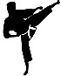Event
Please give the name of the event and the location
Click here to enter text.

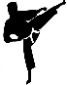Attendees
Please give the name of the team/individuals who attended the event
Click here to enter text.

Results
Please provide the results or a link to where they can be accessed
Click here to enter text.

Highlights
Please include at least one stand out moment from the event
Click here to enter text.

Photos
Minimum one, maximum five, best shots taken at the event
Please either embed images below or attach to the email along with this form

